# Project Two

## Algorithm Cipher

My recommended algorithm of choice is SHA-256. This is a very stable and reliable hash function to use, and while technically speaking collisions can be possible, the probability is extremely low. This algorithm is used in a lot of places in the industry and has in fact never been compromised by itself.

**Screen shots:**

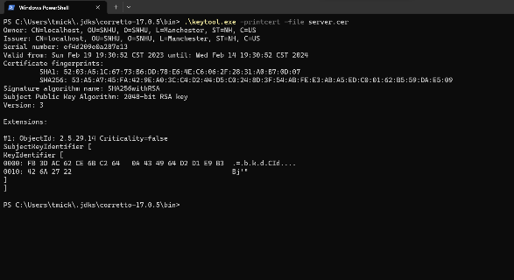

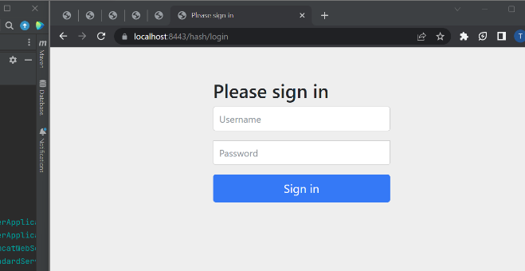

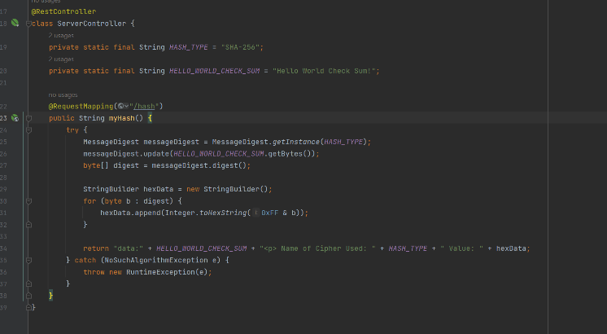

As for the dependency checker, chrome is not letting me access the local host website for whatever reason, but I did follow every correct step and generated the html file in the target directory. I did everything short of opening it and taking a screen shot. Hopefully this is okay.

**Summary**

There wasn’t any base code to re-factor, so I ended up adding code from a previous assignment to achieve the desired goal. The code is simple and serializes the desired string using SHA-256. It’s also very secure as the local website is now using https, whereas before it was only using http. In order to obtain the goal of https, I had to create an SSL certification, and update the application.properties file. This is relevant in any website that uses springboot, as a website nowadays should never be using http rather than https.